PLAQUE Library v 1.0.0 | Plaque library
Author | Ch. Jacquelin

Revision History
Rev | Date  (YYYY-MM-DD) | Author | Reason | Changes
A | 2014-04-002 | CJ | Creation

Table of contents

1 Introduction 3
1.1 Scope 3
1.2 Glossary 3
1.3 References 3
1.4 System Description 3
2 Product Specification 4
2.1 The Plaque API 4
2.1.1 Overview 4
2.1.2 Functions of PlaqueInterface 4
2.1.3 Members of PlaqueResult 7
2.2 Technical specification 7
2.3 Optimal system setup 8
2.4 Visual Design 8

- Introduction
  - Scope
The aim of this specification is to describe the functions provided by LibPlaque.dll

  - Glossary
QI Quality Index
StdD Standard Deviation

  - References
[1] Mannheim Carotid Intima-MediaThickness Consensus (2004–2006),
P.-J. Touboul et al., Cerebrovasc Dis 2007;23:75–80

  - System Description
The LibPlaque.dll library provide functionality related to the calculation of the Plaque based on ultrasound images.

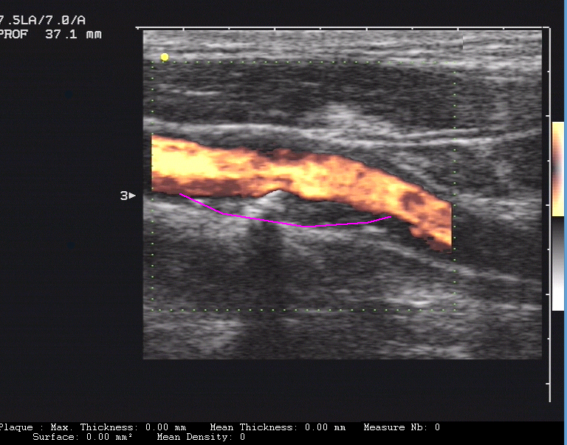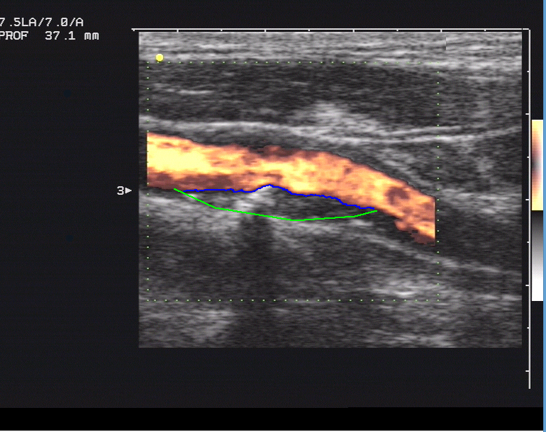
At the right, in green the user edge, and in blue the detected edge.

- Product Specification
LibPlaque.dll provide functions related to the computation of the plaque.
Starting from an ultrasound image, it calculate the plaque:

There are two ways to provide ultrasound images used as input for the calculation:
- Specify the path of a DICOM file, which is then parsed by the library.
- Provide an array of pixels
  - The Plaque API
    - Overview
The library’s interface consists of two files:
- PlaqueInterfaceDll.h provides the interface functions
- PlaqueResult.h describes the container structure PlaqueResult used for calculation results.
    - Functions of PlaqueInterface
      - Image loading

BOOL initializeFromFile( const char* fileName,
double mmPerPixelX = -1.0, double mmPerPixelY = -1.0 );
Loads an (ultrasound) image from a Dicom file.
DICOM files must be conform to DICOM 3 part 10.
Currently only one B-mode region per DICOM file is supported.
Input parameters:
fileName A zero-terminated string containing the absolute file path.
mmPerPixelX,
mmPerPixelY The pixel sizes (in mm) used for image calibration.
These parameters are optional - if you use the default value (-1.0) then the calibration information provided in the DICOM file is applied.
Return values:
TRUE on success and FALSE if the library was not able to load the file
BOOL initializeFromRaw( const char* pixelArray,
int width, int height,
int bitsPerPixel,
BOOL upsideDown,
double mmPerPixelX, double mmPerPixelY );
Loads an image from a pixel array.
When dealing with bitmaps, the calling application needs to load the image using an appropriate GUI library (e.g. CImage object from ATL/MFC on Windows, QImage object from Qt on Linux).
Input parameters:
pixelArray The pixel array containing the image to load.
width, height Width and height of the image (in pixels).
bitsPerPixel Number of bits used per pixel in the array.
The only supported values are 8, 24 and 32.
upsideDown TRUE if the array defines a bottom-up image, otherwise FALSE.
mmPerPixelX,
mmPerPixelY The pixel sizes (in mm) used for image calibration.
Return values:
TRUE on success and FALSE if calibrations are not valid or bitsPerPixel has unsupported value.

      - Image displaying

char* getPixelArray ();
Allows accessing the ultrasound image contained in the library.
It may be used to display the ultrasound image in the user’s application.
Input parameters:
HDC Handle to the display device context used for displaying the image.
x, y Position in HDC where to start image displaying.
width, height The displaying dimensions of the image (in pixels).
If these dimensions differ from the original image size, then the image will be stretched accordingly
Return values:
This method returns a pointer to the pixel array of the image contained in the library.
Depending on the initialization method used, this pointer either points to the DICOM pixel array allocated internally, or to the bitmap pixel array allocated by the calling application.
If no image is loaded the function returns NULL.

int getImageBitsPerPixel ();
Returns the the number of bits each pixel of the loaded Image occupies.
This function is intended to be used for accessing the pixels returned by getPixelArray().
If no image is loaded the function returns zero.

int getImageWidth();
Returns the width of the image loaded in the library.
This function is intended to be used for accessing the pixels returned by getPixelArray().
If no image is loaded the function returns zero.

int getImageHeight();
Returns the height of the image loaded in the library.
This function is intended to be used for accessing the pixels returned by getPixelArray().
If no image is loaded the function returns zero.

      - Plaque Measure computation

Function ComputePlaque :

int PlaqueInterface::computePlaque( int x, int y, int nbPts, unsigned char *points, CPlaqueResult* result, int seuil1, int seuil2 );

Input parameters:
x, y : coordinates of the point on the plaque, last point entered by the user.

nbPts : Number of points of the manual edge.

points : Array of points for the manual edge of the plaque.

Result : The result structure pointer.

seuil1 : Minimal threshold for the plaque analysis algorithm.

seuil2 : Maximal threshold for the plaque analysis algorithm.

Return values:
State of the function

Function GetResult :

CPlaqueResult PlaqueInterface::GetResult();

Input parameters:
None

Return values:
Return the PlaqueResult Structure
    - Members of PlaqueResult

double plaque_max_thickness;
Measure of the maximum thickness of the plaque.

double plaque_mean_thickness;
Measure of the mean thickness of the plaque.

double plaque_area;
Measure of the area of the plaque.

double plaque_mean_density;
Measure of the mean density of the plaque.

int numberOfMeasures;
Number of measures made by the algorithm.

int m_type;
Type of image : color or BW.

int m_Etape;
Internal step in the algorithm

Point *m_tPtLongeantPlaque;
Array of points of the manual edge.

int m_nPtLongeantPlaque;
Number of points of the manual edge.

Point *m_tbPtsTrouvesFin;
Array of point of the detected edge.

int m_nVecteursTrouves;
Number of points of the detected edge.

Point m_ptInferieur;
Point clicked by the user on the plaque.

unsigned char *m_dataImg;
long m_nbpix;
Image of result (and number of pixels), used for the plaque analysis. (in option)
  - Technical specification
LibPlaqueDLL.dll runs for Windows 8.1, and Linux Debian.

The library requires just enough RAM to keep the biggest possible dataset in memory
Generally there are no limitations to screen size

Used third party products:
- DCMTK 3.5.4
None of the above third party products requires licensing.
  - Optimal system setup
For an optimal result, the user must acquire a CENTRAL plane through the vessel.

Recommendations for the ultrasound system are:
- Frequency range from 7 to 12 MHz
- Imaging depth between 30 and 45 mm
- Optimization of gain settings and minimization of artifacts in the lumen of the vessel
See also [1].
  - Visual Design
The library comes without any graphical user interface. All GUI must be implemented by the customer.

